**California State University, Northridge**

**College of Engineering & Computer Science**

**Electrical and Computer Engineering Department**

**ECE 443L Digital Electronics Laboratory Report 10**

**CMOS based Comparator Circuit Design, Simulation and Experimental Test as well as Analysis**

**By Evan Thomas, Haroutun Haroutunian,**

**Clayton Lawton**



**Professor: Sequare Daniel-Berhe**

**Abstract:**

Lab 4 exposes students of Comparators and their functionalities in everyday electronics. A comparator is simply a device which compares 2 input voltages or currents and outputs indicating which signal was larger. Comparators are largely utilized in Analog-to-digital converters, which are found in almost every advanced electronic.

**Key Terms:**

Comparator, ADC, converter

**Simulation and Experimental Result:**

Figure 4.1: Case 1 EVAN Comparator Schematic @ 25kHz and 50kHz

Figure 4.2: Case 1 EVAN Comparator Waveform and Cursor @ 25kHz and 50kHz

Figure 4.3: Case 1 EVAN Comparator Circuit Result @ 1kHz and 2kHz

Figure 4.4: Case 1 CLAYTON Comparator Schematic @ 25kHz and 50kHz

Figure 4.5: Case 1 CLAYTON Comparator Waveform @ 25kHz and 50kHz

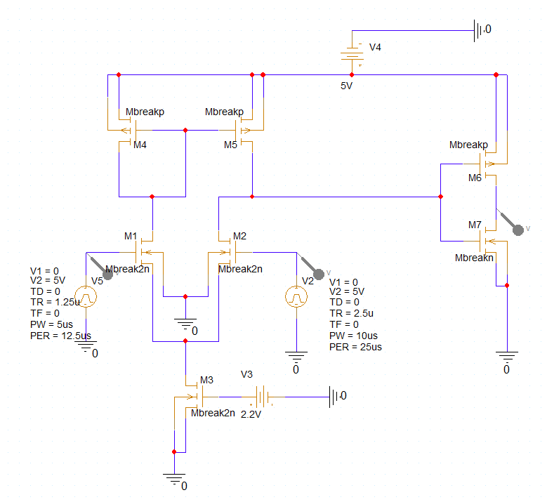

Figure 4.6: Case 2 HAROUTUN Comparator Schematic @ 20kHz and 40kHz

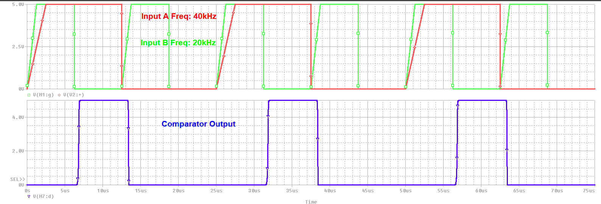

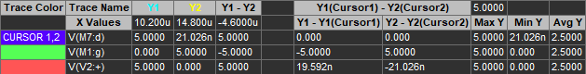

Figure 4.7: Case 2 HAROUTUN Comparator Waveform @ 20kHz and 40kHz

Figure 4.8: Case 3 EVAN Comparator Schematic @ 50kHz and 4V

Figure 4.9: Case 3 EVAN Comparator Waveform @ 50kHz and 4V

Figure 4.10: Case 3 EVAN Comparator Circuit Output @ 1kHz and 3.92V

Figure 4.11: Case 3 CLAYTON Comparator Schematic @ 50kHz and 4V

Figure 4.12: Case 3 CLAYTON Comparator Waveform @ 50kHz and 4V

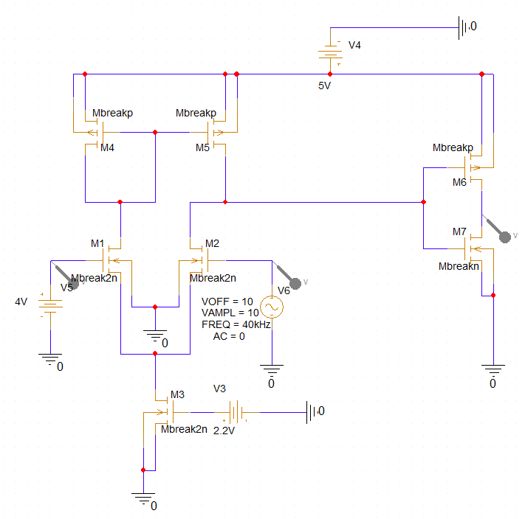

Figure 4.13: Case 4 HAROUTUN Comparator Schematic @ 40kHz and 4V

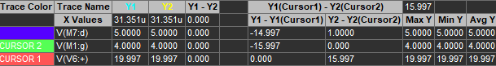

Figure 4.14: Case 4 HAROUTUN Comparator Waveform @ 40kHz and 4V

Figure 4.15: Case 5 EVAN Comparator Waveform @ 25kHz and 50kHz

Figure 4.16: Case 5 EVAN Comparator Waveform @ 25kHz and 50kHz

Figure 4.17: Case 5 EVAN Comparator Circuit Output @ 2kHz and 996Hz

Figure 4.18: Case 5 CLAYTON Comparator Schematic @ 25kHz and 50kHz

Figure 4.19: Case 5 CLAYTON Comparator Waveform @ 25kHz and 50kHz

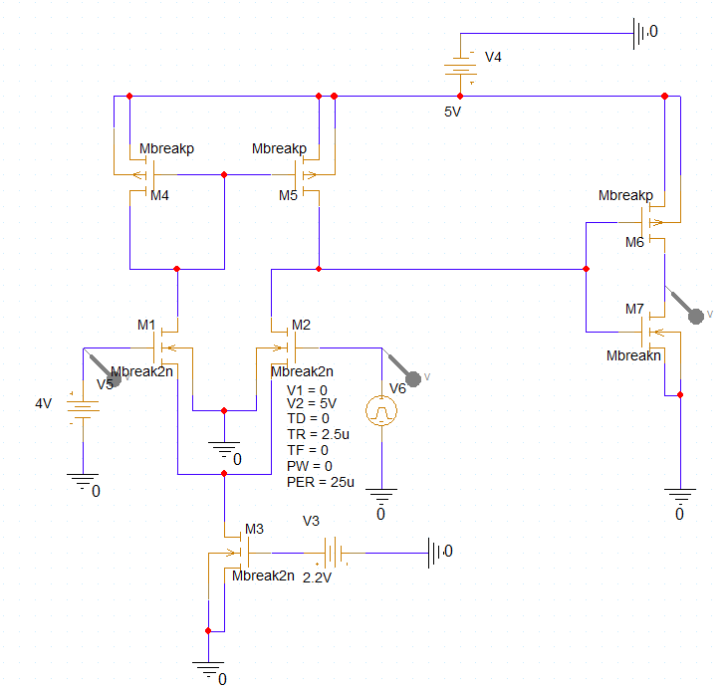

Figure 4.20: Case 6 HAROUTUN Comparator Schematic @ 40kHz and 4V

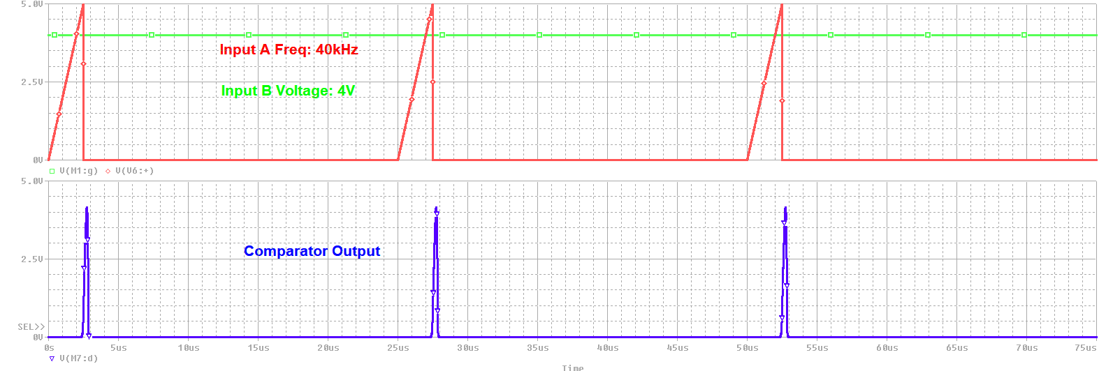

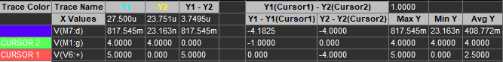

Figure 4.21: Case 6 HAROUTUN Comparator Waveform @ 40kHz and 4V

**Conclusion:**

Students not only constructed a comparator on the advanced software PSpice but recreated the circuit on a breadboard. As seen in figure 4.17, the comparator functions properly, indicating which input signal was higher. Comparators are found in almost every electronics which allows engineers to produce circuits based upon the comparative result of 2 signals.